**MAHARAJA SURAJMAL INSTITUTE**

**Affiliated to GGSIP University & NAAC ‘A’ grade accredited**



**DEPARTMENT OF COMPUTER**

**APPLICATIONS**

**WEB TECHNOLOGIES**

**Practical File**

**Subject Code – BCA 175**

**SUBMITTED BY SUBMITTED TO**

**Aman Tripathi Mrs. Nikita Malik**

**111146215262 Assistent Professor. MSI**

**1st Sem, 2nd Shift**

| **S.No.** | **Date** | **Content** |
| --- | --- | --- |
| 1. | 16/12/2021 | Create your resume using various basic HTML tags. |
| 2. | 17/12/2021 | Create the timetable of your class using HTML tags. |
| 3. | 23/12/2021 | Create the following unordered/ordered nested list as shown in the figure. |
| 4. | 24/12/2021 | Create a web page with the following specifications:  a) an ordered list containing the names of your friends.  b) an unordered list specifying hobbies.  c) some links to various search engines.  d) links to five different web pages, created by you, opening in a new  window.  e) a link at the top of the page so that when clicked jump all way to the  bottom of the page.  f) a link at the bottom of the page so that when clicked jump all way to the  top of the page. |
| 5. | 30/12/2021 | Create the following table as shown using HTML. |
| 6. | 31/12/2021 | Create the following form in HTML as shown in the figure. |
| 7. | 03/01/2022 | Create an online application form having the following specifications:  a) position applied for(autofocus), name, nationality, gender, date of birth  (Selected from auto picked of a text area), address, telephone number  and email(required), password(required).  b) educational history, qualifications and skills(checkbox).  c) work experience/employment/training in terms of employer history  and number of years of experience selected from a slider. Set max.  years of experience to 10 years.  d) personal statement.  e) two referees including names, occupation, relationship, address,  telephone.  a submit and clear button. |
| 8. | 04/01/2022 | Create a web page showing India's map and create hotspots on five different states and link them to the e-government sites of the respective states. |
| 9. | 05/01/2022 | Create a web page using three frames and link them to an image, audio and  video as shown in the figure. |
| 10. | 06/01/2022 | Create a web page having six frames and link each frame with five different web pages. |
| 11. | 07/01/2022 | Create the following frameset as shown in the figure. |
| 12. | 07/01/2022 | Create an Iframe and write some lines before and after it. |

Practical 1

Theory:-

What is HTML?

• HTML stands for HyperText Markup Language

• HTML is the standard markup language for creating Web pages

• HTML describes the structure of a Web page

• HTML consists of a series of elements

• HTML elements tell the browser how to display the content

• HTML elements label pieces of content such as "this is a heading", "this is a paragraph", "this is a link", etc.

• HTML language is not case sensitive.

HTML Elements

The HTML element is everything from the start tag to the end tag:

<tagname>Content goes here...</tagname>

Some HTML elements have no content (like the <br> element). These elements are called empty elements. Empty elements do not have an ending tag.

HTML elements can be nested (this means that elements can contain other elements.

HTML Attributes

• All HTML elements can have attributes

• Attributes provide additional information about elements

• Attributes are always specified in the start tag

• Attributes usually come in name/value pairs like: name="value"

1. The href attribute:- The <a> tag defines a hyperlink. The href attribute specifies the URL of the page the link goes to.

2. The src attribute:- The <img> tag is used to embed an image in an HTML page. The src attribute specifies the path to the image to be displayed.

3. The width and height attribute:- The tags should also contain the width and height attributes, which specifies the width and height.

4. The alt attribute:- The required alt attribute for the <img> tag specifies an alternate text for an image if the image for some reason cannot be displayed. This can be due to slow connection, or an error in the src attribute, or if the user uses a screen reader.

5. The style attribute:- The style attribute is used to add styles to an element, such as color, font, size, and more.

6. The lang attribute:- You should always include the lang attribute inside the <html> tag, to declare the language of the Web page. This is meant to assist search engines and browsers.

7. The title attribute:- The title attribute defines some extra information about an element. The value of the title attribute will be displayed as a tooltip when you mouse over the element.

HTML Documents

i. All HTML documents must start with a document type declaration: <!DOCTYPE html>. The <!DOCTYPE> declaration represents the document type, and helps browsers to display web pages correctly. It must only appear once, at the top of the page (before any HTML tags).

ii. The HTML document itself begins with <html> and ends with </html>.

iii. The visible part of the HTML document is between <body> and </body>.

HTML Headings

HTML headings are defined with the <h1> to <h6> tags. <h1> defines the most important heading. <h6> defines the least important heading.

<h1>Heading 1</h1>

<h2>Heading 2</h2>

<h3>Heading 3</h3>

<h4>Heading 4</h4>

<h5>Heading 5</h5>

<h6>Heading 6</h6>

HTML Paragraphs

HTML paragraphs are defined with the <p> tag. These tags are used to define a block of text as a paragraph. HTML paragraphs can be any structural grouping of related content, such as images or form fields.

<p>This is a paragraph.</p>

<p>This is another paragraph.</p>

HTML Horizontal Rule

The <hr> tag defines a thematic break in an HTML page, and is most often displayed as a horizontal rule. This element is used to separate content (or define a change) in an HTML page. It is an empty tag.

HTML Line Break

The HTML <br> element defines a line break. Use <br> if you want a line break (a new line) without starting a new paragraph. It is an empty tag.

HTML Tags Formatting

HTML contains several elements for defining text with a special meaning. Formatting elements were designed to display special types of text:

• <b> - Bold text

• <strong> - Important text

• <i> - Italic text

• <em> - Emphasized text

• <mark> - Marked text

• <small> - Smaller text

• <del> - Deleted text

• <ins> - Inserted text

• <sub> - Subscript text

• <sup> - Superscript tex

HTML Lists

HTML lists allow web developers to group a set of related items in lists.

An unordered list starts with the <ul> tag. Each list item starts with the <li> tag. The list items will be marked with bullets (small black circles) by default.

An ordered list starts with the <ol> tag. Each list item starts with the <li> tag. The list items will be marked with numbers by default.

HTML also supports description lists. A description list is a list of terms, with a description of each term. The <dl> tag defines the description list, the <dt> tag defines the term (name), and the <dd> tag describes each term

An unordered HTML list: A description list:-

• Item Coffee

• Item - black hot drink

• Item Milk

• Item - white cold drink

An ordered HTML list:

1. First item

2. Second item

3. Third item

HTML Links

HTML links are defined with the <a> tag. The link tag is used to define a link between a document and an external resource. The link tag is mainly used to link to external style sheets. This element can appear multiple times but it goes only in the head section.

HTML Images

HTML images are defined with the <img> tag. The HTML <img> tag is used to embed an image in a web page. Images are not technically inserted into a web page; images are linked to web pages. The <img> tag creates a holding space for the referenced image. The <img> tag is empty, it contains attributes only, and does not have a closing tag.

The <img> tag has two required attributes:

• src - Specifies the path to the image

• alt - Specifies an alternate text for the image

Code:-

<!DOCTYPE html>

<html lang="en">

<head>

<meta charset="UTF-8" />

<meta http-equiv="X-UA-Compatible" content="IE=edge" />

<meta name="viewport" content="width=device-width, initial-scale=1.0" />

<title>Resume</title>

</head>

<body>

<div>

<center>

<img style="border-radius: 50%" src="Media/Untitled design (3).png" width=" 200px" alt="Pofile" />

</center>

<h2 style="text-align: center">

Aman Tripathi <br />Email:- imamantripathi@gmail.com <br />Contact No.:-

8126406617

</h2>

</div>

<h2 style="padding-left: 100px"><u>Objective</u></h2>

<p style="padding-left: 100px; padding-right: 200px; font-size: medium">

<b>Looking for opportunities to incorporate my skills and training to help

the company grow. I am looking forward to roles that will help me

realise my potential by exploring the various aspects of this field.</b>

</p>

<div style="padding-left: 55px">

<ul>

<h2><u>Education Qualification</u></h2>

<li style="font-size: medium">

<b>10th passed from ICSE Board with 81% (2019) </b>

</li>

<li style="font-size: medium">

<b>I got 100/100 Marks in Computer Applications </b>

</li>

<li style="font-size: medium">

<b>12th passed from ISC Board with 80.8% (2021) </b>

</li>

<li style="font-size: medium">

<b>I received a certificate in code jam 2021 </b>

</li>

</ul>

</div>

<div style="padding-left: 55px">

<ul>

<h2><u>Professional Qualification</u></h2>

<li style="font-size: medium">

<b>Basic Knowledge of Computer </b>

</li>

<li style="font-size: medium">

<b>Complete Knowledge of JAVA </b>

</li>

<li style="font-size: medium">

<b>Complete Knowledge of HTML </b>

</li>

<li style="font-size: medium">

<b>Intermediate Knowledge of CSS </b>

</li>

<li style="font-size: medium">

<b>Basic knowledge of JAVASCRIPT </b>

</li>

</ul>

</div>

<div style="padding-left: 55px">

<ul>

<h2><u>Hobbies</u></h2>

<li style="font-size: medium">

<b>Reading books </b>

</li>

<li style="font-size: medium">

<b>Playing Chess</b>

</li>

<li style="font-size: medium">

<b>Listening Music </b>

</li>

<li style="font-size: medium">

<b>Playing an instrument </b>

</li>

<li style="font-size: medium">

<b>Writing & Art </b>

</li>

</ul>

</div>

<div style="padding-left: 55px">

<ul>

<h2><u>Interests</u></h2>

<li style="font-size: medium">

<b>History(Indian Modern History) </b>

</li>

<li style="font-size: medium">

<b>Website Development</b>

</li>

<li style="font-size: medium">

<b>Travelling </b>

</li>

<li style="font-size: medium">

<b>Research in IT Sector </b>

</li>

<li style="font-size: medium">

<b>Android Development</b>

</li>

<li style="font-size: medium">

<b>Producing or listening music </b>

</li>

</ul>

</div>

<br /><br />

<address style="

font-size: x-large;

font-weight: bold;

text-align: right;

padding-right: 200px;

">

Aman Tripathi

</address>

<br /><br /><br />

</body>

</html>

Output:-



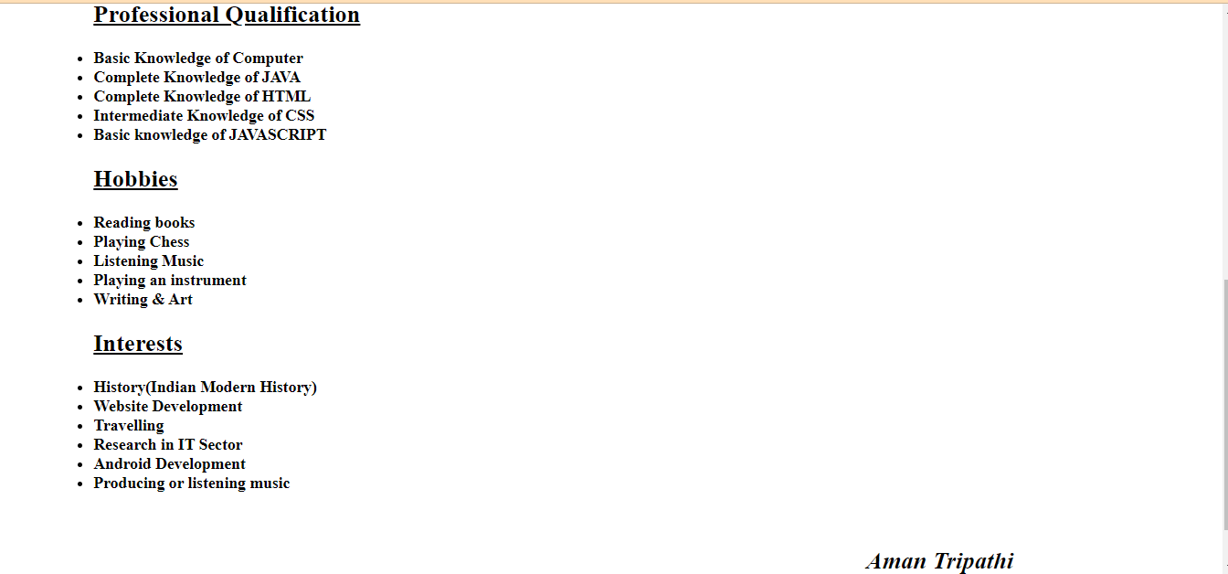

Practical 2

Theory:-

HTML Tables

HTML tables allow web developers to arrange data into rows and columns. It consists of table cells inside rows and columns.

Tag Description

<table> Defines a table

<th> Defines a header cell in a table

<tr> Define a row in a table

<td> Define a cell in a table

<colspan> Merges columns

<rowspan> Merges rows

<caption> Defines a table caption

Code:-

<html lang="en">

<head>

<meta charset="UTF-8" />

<meta http-equiv="X-UA-Compatible" content="IE=edge" />

<meta name="viewport" content="width=device-width, initial-scale=1.0" />

<title>Collage TimeTable</title>

<style>

* {

padding-top: 25px;

padding-left: 10px;

padding-right: 10px;

margin: 0;

}

table,

th,

td {

border: 2px solid black;

}

table {

border-collapse: collapse;

}

th,

td {

text-align: center;

padding: 5px 20px 5px 20px;

}

div {

padding: 10px 300px 50px 250px;

border: 1px solid black;

border-radius: 10px;

}

caption {

text-decoration: none;

font-weight: bolder;

font-family: "Lucida Sans", "Lucida Sans Regular", "Lucida Grande",

"Lucida Sans Unicode", Geneva, Verdana, sans-serif;

}

</style>

</head>

<body>

<div style="table-layout: fixed">

<table>

<thead>

<caption>

Maharaja Surajmal Institute

<br /><b>Department Of Computer Application</b>

<br />Online Timetable Second Shift (Session:- DEC-MAY 2021)

</caption>

<caption style="padding: 0%; padding-bottom: 20px;">

<u>BCA-FIRST SEM-Secton:A(Second Shift)</u>

<br />Class Coordinator: Ms. Nikita Malik

</caption>

<tr>

<th>DAY/TIME</th>

<th>8:50-9:50</th>

<th>9:55-10:55</th>

<th>11:00-12:00</th>

<th>12:05-01:05</th>

<th>01:05-01:20</th>

<th>01:20-02:20</th>

<th>02:25-03:25</th>

</tr>

</thead>

<tbody>

<tr>

<th>MON</th>

<td>WT</td>

<td>MATHS</td>

<td>TC</td>

<td>C</td>

<td rowspan="6">LUNCH</td>

<td colspan="2">WT/C LAB</td>

</tr>

<tr>

<th>TUE</th>

<td>MATHS</td>

<td>WT</td>

<td colspan="2">WT/C LAB</td>

<td colspan="2">FIT LAB</td>

</tr>

<tr>

<th>WED</th>

<td>C</td>

<td>MATHS</td>

<td>WT</td>

<td>FIT</td>

<td>TC</td>

</tr>

<tr>

<th>THU</th>

<td>TC</td>

<td>C</td>

<td colspan="2">WT/C LAB</td>

<td>FIT</td>

<td>MATHS(A+B Bridge)</td>

</tr>

<tr>

<th>FRI</th>

<td colspan="2">WT/C LAB</td>

<td>C</td>

<td>FIT</td>

<td>TC</td>

<td>WT</td>

</tr>

<tr>

<th>SAT</th>

<td>MATHS</td>

<td>FIT</td>

<td colspan="2">FIT LAB</td>

<td>MATHS(A+B Bridge)</td>

</tr>

</tbody>

</table>

<p style="padding: 0%;">

<b>Maths:-</b>Dr. Jyoti, <b>FIT:-</b>Mr. Suraj Pal Chauhan,

<b>C:-</b>Ms. Minal Dhankar, <br><b>WT:-</b>Ms. Nikita Malik,

<b>TC:-</b>Manju Dhillon, <b>C Lab:-</b> Ms. Minal Dhankar, <br>

<b>FIT Lab:-</b>Mr. Suraj Pal Chauhan / Ms. Kanika Kundu, <b>WT Lab:-</b

>Ms. Nikita Malik

</p>

</div>

</body>

</html>

Output:-

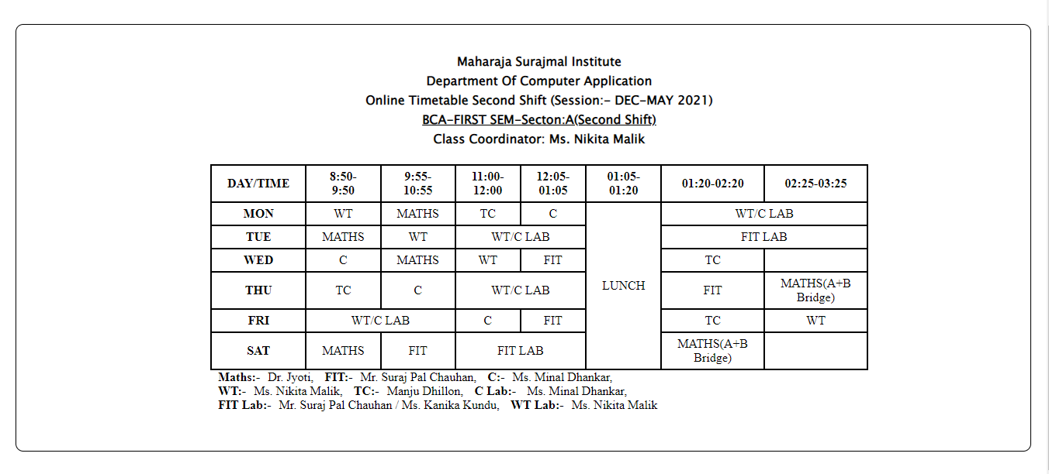

Practical 3

Code:-

<html lang="en">

<head>

<meta charset="UTF-8" />

<meta http-equiv="X-UA-Compatible" content="IE=edge" />

<meta name="viewport" content="width=device-width, initial-scale=1.0" />

<title>List</title>

<style>

body {

align-content: center;

}

div {

font-family: "Lucida Sans", "Lucida Sans Regular", "Lucida Grande",

"Lucida Sans Unicode", Geneva, Verdana, sans-serif;

font-size: medium;

}

</style>

</head>

<body>

<div style="background-color: white">

<h1>Learning Web Development</h1>

<ol type="I">

<li>

Background Skills

<ol type="A">

<li>Unix Commands</li>

<li>Vim Text Editor</li>

</ol>

</li>

<li>

HTML

<ol type="A">

<li>Minimal page</li>

<li>Headings</li>

<li>Tags</li>

<li>

Lists

<ol type="i">

<li>Unordered</li>

<li>Ordered</li>

<li>Definition</li>

<li>Nested</li>

</ol>

</li>

<li>

Links

<ol type="i">

<li>Absolute</li>

<li>Relative</li>

</ol>

</li>

<li>Images</li>

</ol>

</li>

<li>

CSS

<ol type="A">

<li>Anatomy</li>

<li>

Basic Selectors

<ol type="i">

<li>Elements</li>

<li>Class</li>

<li>ID</li>

<li>Group</li>

</ol>

</li>

<li>The DOM</li>

<li>Advanced Selectors</li>

<li>Box Model</li>

</ol>

</li>

<li>

Programming

<ol type="A">

<li>Python</li>

<li>Javascript</li>

</ol>

</li>

<li>

Database

<ol type="A">

<li>Flat File</li>

<li>Relational</li>

</ol>

</li>

</ol>

</div>

</body>

</html>

Output:-

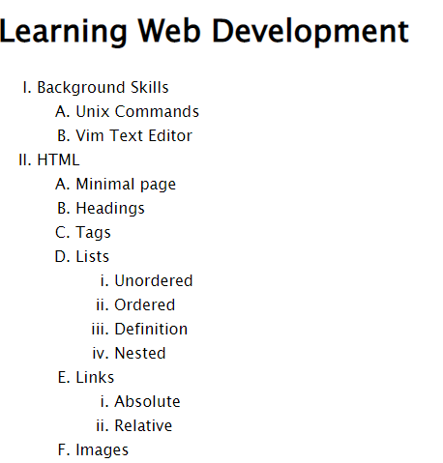

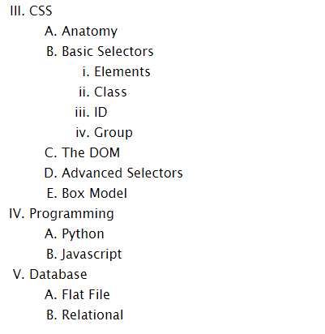

Practical 4

Theory:-

HTML id attribute

The id attribute specifies a unique id for an HTML element. The value of the id attribute must be unique within the HTML document. The syntax for id is: write a hash character (#), followed by an id name.

Anchor Tag

The <a> tag defines a hyperlink, which is used to link from one page to another.

The most important attribute of the <a> element is the href attribute, which indicates the link's destination.

By default, links will appear as follows in all browsers:

• An unvisited link is underlined and blue

• A visited link is underlined and purple

• An active link is underlined and red

Code:-

<html lang="en">

<head>

<meta charset="UTF-8" />

<meta http-equiv="X-UA-Compatible" content="IE=edge" />

<meta name="viewport" content="width=device-width, initial-scale=1.0" />

<title>Practical 4 (Web Page)</title>

<style>

a {

text-decoration: none;

color: black;

}

</style>

</head>

<body>

<div id="top"></div>

<center>

<a href="#bottom" style="color: red; font-weight: bold; font-size: x-large">Go to Bottom Section</a>

</center>

<h3>Name of my friends:</h3>

<ol>

<li>Vipin Buddha</li>

<li>Raj Kumar</li>

<li>Tushar Sharma</li>

<li>Yashu Varshney</li>

<li>Gagan Tripathi</li>

</ol>

<h3>List of my hobbies:</h3>

<ul>

<li>Reading Books</li>

<li>Playing Chess</li>

<li>Traveling</li>

<li>Designing</li>

</ul>

<h3>Links for Various Search Engines:</h3>

<ul>

<li><a target="_blank" href="https://www.google.com/">Google</a></li>

<li><a target="_blank" href="https://www.bing.com/">Bing</a></li>

<li><a target="_blank" href="https://www.baidu.com/">Baidu</a></li>

<li><a target="_blank" href="https://www.yahoo.com/">Yahoo!</a></li>

<li><a target="_blank" href="https://yandex.com/">Yandex</a></li>

<li><a target="_blank" href="https://www.ask.com/">Ask</a></li>

</ul>

<h3>List of Diffrent Webpages:</h3>

<ul>

<li>

<a target="_blank" href="Resume_Practical_1.html">Practical 1 (Resume)</a>

</li>

<li>

<a target="_blank" href="TimeTable_Practical_2.html">Practical 2 (Timetable)</a>

</li>

<li>

<a target="_blank" href="List_Practical_3.html">Practical 3 (List)</a>

</li>

<li>

<a target="_blank" href="Webpage_Practical_4.html">Practical 4 (Webpage)</a>

</li>

<li>

<a target="_blank" href="Table_Practical_5.html">Practical 5 (Image_Table)</a>

</li>

<li>

<a target="_blank" href="Form_Practical_6.html"> Practical 6 (Form)</a>

</li>

</ul>

<center>

<a href="#top" style="color: red; font-weight: bold; font-size: x-large">Go to Top Section</a>

</center>

<div id="bottom"></div>

</body>

</html>

Output:-

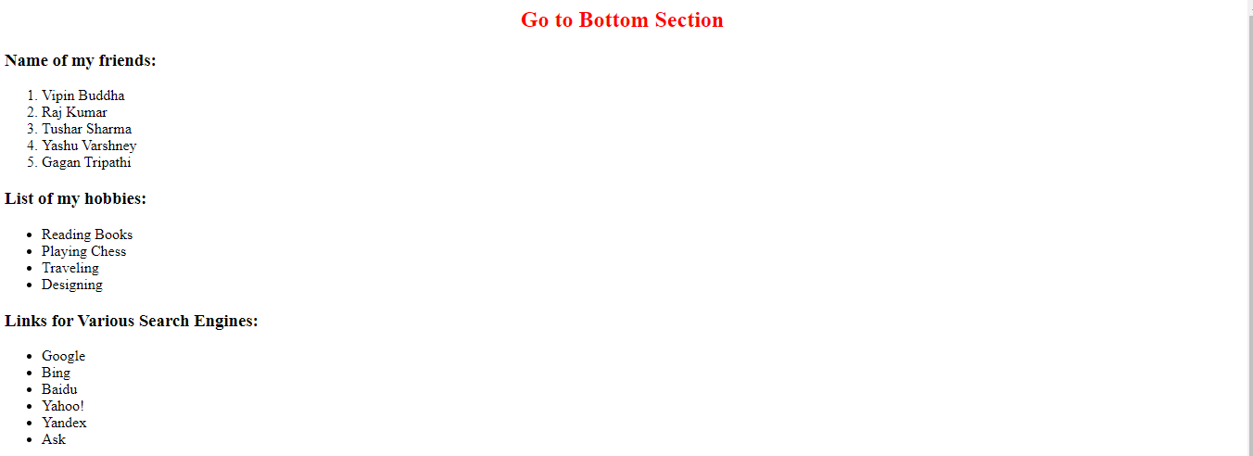

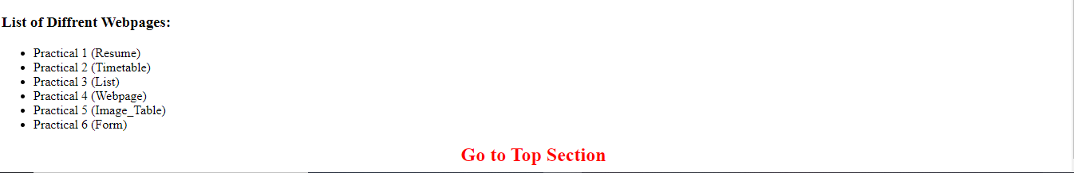

Practical 5

Code:-

<html lang="en">

<head>

<meta charset="UTF-8" />

<meta http-equiv="X-UA-Compatible" content="IE=edge" />

<meta name="viewport" content="width=device-width, initial-scale=1.0" />

<title>Document</title>

<style>

td {

border: 1px solid black;

}

table {

border: 5px solid black;

}

div {

padding: 20px 400px 20px 350px;

}

</style>

</head>

<body>

<div>

<table>

<tbody>

<tr>

<td>

<img

src="Media/IMG_20210227_003056_487.jpg"

width="150px"

alt="Image"

/>

</td>

<td>

<img

src="Media/IMG_20210325_205201_770.jpg"

width="150px"

alt="Image"

/>

</td>

<td>

<img

src="Media/IMG_20210506_080037_099.jpg"

width="150px"

alt="Image"

/>

</td>

<td>

<img

src="Media/IMG_20210510_171515_975.jpg"

width="150px"

alt="Image"

/>

</td>

</tr>

<tr>

<td>

<img

src="Media/IMG_20210519_120425_393.jpg"

width="150px"

alt="Image"

/>

</td>

<td

colspan="2"

style="

text-align: center;

font-size: larger;

font-family: cursive;

background: goldenrod;

"

>

Table with Images

</td>

<td>

<img

src="Media/IMG_20210227_003056_487.jpg"

width="150px"

alt="Image"

/>

</td>

</tr>

<tr>

<td>

<img

src="Media/IMG_20210325_205201_770.jpg"

width="150px"

alt="Image"

/>

</td>

<td>

<img

src="Media/IMG_20210506_080037_099.jpg"

width="150px"

alt="Image"

/>

</td>

<td>

<img

src="Media/IMG_20210510_171515_975.jpg"

width="150px"

alt="Image"

/>

</td>

<td>

<img

src="Media/IMG_20210519_120425_393.jpg"

width="150px"

alt="Image"

/>

</td>

</tr>

</tbody>

</table>

</div>

</body>

</html>

Output:-



Practical 6

Theory:-

HTML <form> tag

An HTML form is a section of a document which contains controls such as text fields, password fields, checkboxes, radio buttons, submit button, menus etc.

An HTML form facilitates the user to enter data that is to be sent to the server for processing such as name, email address, password, phone number, etc. .

The <form> tag is used to create an HTML form for user input. The <form> element can contain one or more of the following form elements:

• <input> :- It defines an input control.

• <textarea> :- It defines a multi-line input control.

• <button> :- It defines a clickable button

• <select> :- It defines a drop-down list.

• <option> :- It defines an option in a drop-down list.

• <optgroup> :- It defines a group of related options in a drop down list.

• <fieldset> :- It groups the related element in a form.

• <label> :- It defines a label in an input element.

• <output> :- It defines the result of a calculation.

<label> tag

It is considered better to have label in form. As it makes the code parser/browser/user friendly. If you click on the label tag, it will focus on the text control. To do so, you need to have for attribute in label tag that must be same as id attribute of input tag.

Input type

• Password :- The password is not visible to the user in password field control.

• Email :- The email field in new in HTML 5. It validates the text for correct email address. You must use @ and . in this field.

• Radio :- The radio button is used to select one option from multiple options. It is used for selection of gender, quiz questions etc.

• Checkbox :- The checkbox control is used to check multiple options from given checkboxes.

• Submit :- HTML <input type="submit"> are used to add a submit button on web page. When user clicks on submit button, then form get submit to the server.

Code:-

<html lang="en">

<head>

<meta charset="UTF-8" />

<meta http-equiv="X-UA-Compatible" content="IE=edge" />

<meta name="viewport" content="width=device-width, initial-scale=1.0" />

<title>Form</title>

<style>

form{

font-family: Cambria, Cochin, Georgia, Times, 'Times New Roman', serif;

font-size: larger;

font-weight: bold;

text-align: left;

padding: auto;

}

</style>

</head>

<body>

<hr />

<h2

style="

font-family: 'Franklin Gothic Medium', 'Arial Narrow', Arial, sans-serif;

text-align: center;

"

>

COMPUTER SOCIETY OF INDIA ANNUAL CONVENTION 2022 PARTICIPANTS RECORD

</h2>

<hr />

<div>

<form action="form.php">

<label for="name"> 1. Name of Participant: </label>

<input type="text" id="name" placeholder="Enter Your Name" />

<br />

<br />

<label for="address"> 2. Address: Street </label>

<input type="text" id="address" placeholder="Street Name" />

<label for="town"> Town </label>

<input type="text" id="town" placeholder="Town Name" />

<br /><br />

<label for="state">State</label>

<input type="text" id="state" placeholder="State Name" />

<label for="pincode">Pincode</label>

<input type="number" id="pincode" placeholder="Enter Pincode " />

<br /><br />

<label for="work">3. Select the work you are involved:</label>

<select name="work" id="work">

<option value="no-work">Select your choice</option>

<option value="Computer Education">Computer Education</option>

<option value="Website Development">Website Development</option>

<option value="Application Development">

Application Development

</option>

</select>

<br /><br />

<label for="tutorial">4. Select any tutorial you with to Attend:</label>

<br />

<label for="Tutorial"> 16<sup>th</sup> April 2022</label>

<select name="tutorial" id="tutorial">

<option value="no-option">Select your choice</option>

<option value="E-commerce">E-commerce</option>

<option value="web Tech">Website Technology</option>

<option value="Android Development">Android Development</option>

<option value="Digital Marketing">Digital Marketing</option>

</select>

<label for="Tutorial"> 17<sup>th</sup> April 2022</label>

<select name="tutorial" id="tutorial">

<option value="no-option">Select your choice</option>

<option value="E-commerce">E-commerce</option>

<option value="web Tech">Website Technology</option>

<option value="Android Development">Android Development</option>

<option value="Digital Marketing">Digital Marketing</option>

</select>

<br /><br />

<label for="requirements">5. Type any of your requirements in the Box:</label>

<br />

<textarea rows="10" cols="30" id="requirements"></textarea>

<br /><br />

<input type="reset" value="Start over" />

<input type="submit" value="Send over" />

</form>

</div>

</body>

</html>

Output:-

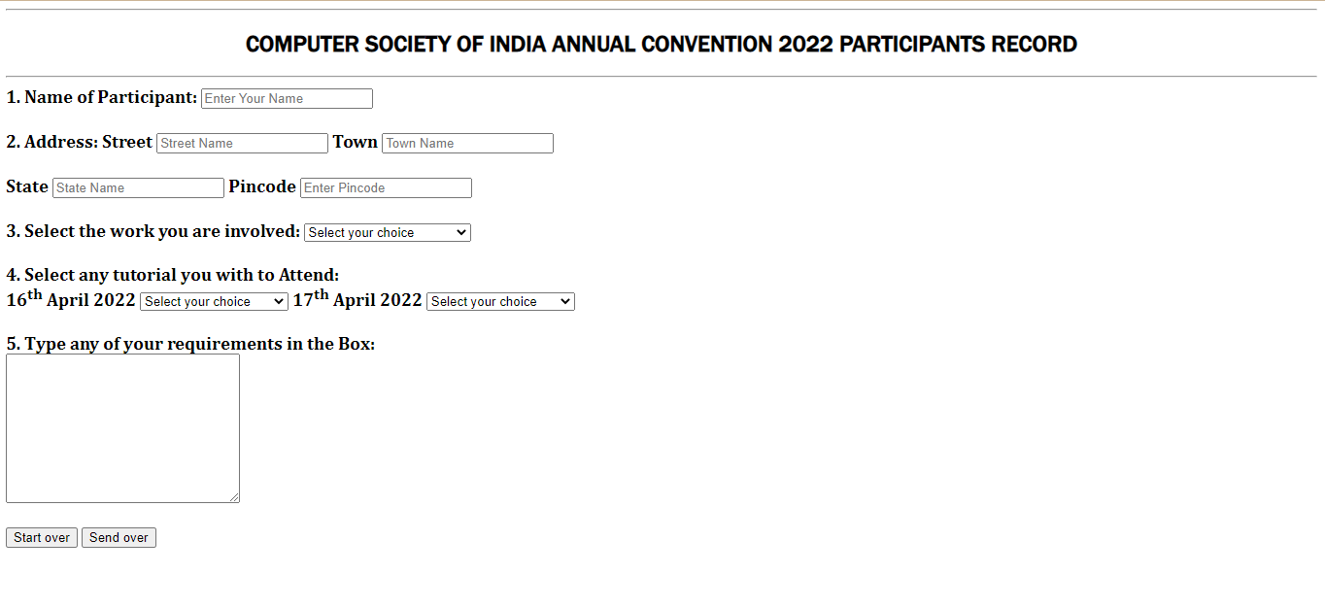

Practical 7

Code:-

<html lang="en">

<head>

<meta charset="UTF-8" />

<meta http-equiv="X-UA-Compatible" content="IE=edge" />

<meta name="viewport" content="width=device-width, initial-scale=1.0" />

<title>Online Application Form</title>

</head>

<body>

<h2

style="

font-family: 'Franklin Gothic Medium', 'Arial Narrow', Arial, sans-serif;

text-align: center;

"

>

Online Application Form

</h2>

<div>

<form action="/form.php">

<label for="position">Position Applied For:</label

><input type="text" autofocus id="position" /> <br /><br />

<label for="name">Enter Your Name:</label>

<input type="text" id="name" placeholder="" />

<br /><br />

<label for="nationality">Enter Your Nationality:</label>

<input type="text" name="nationality" id="nationality" /><br /><br />

<label for="gender">Select Your Gender:</label><br />

<input type="radio" name="gender" value="male" /> Male<br />

<input type="radio" name="gender" value="female" /> Female<br />

<input type="radio" name="gender" value="other" /> Other

<br />

<br />

<label for="dob">Date Of Birth:</label>

<input type="date" id="dob" name="dateofbirth" value="" min="" max="" />

<br />

<br />

<label for="address">Enter Your Address:</label>

<textarea name="address" id="address" cols="20" rows="5"></textarea>

<br /><br />

<label for="telephone_number">Enter Your Number:</label>

<input type="number" name="number" id="telephone_number" /> <br /><br />

<label for="Email"> Enter Your Email: </label>

<input type="email" required name="email" id="Email" />

<br /><br />

<label for="passward">Enter Your Password:</label>

<input type="password" name="passward" required id="passward" />

<br /><br />

<label for="education">Educational History:</label><br />

<input type="checkbox" name="12th" id="education" />12th Class Student

<br />

<input type="checkbox" name="BCA" id="education" />BCA Student

<br /><br />

<label for="qualification">Qualification:</label><br />

<input type="checkbox" name="12th pass" id="qualification" />12th Pass

<br />

<input type="checkbox" name="undergraduate" id="qualification" /> Under

Graduate <br />

<input type="checkbox" name="graduate" id="qualification" /> Graduate

<br />

<input type="checkbox" name="postgraduate" id="qualification" /> Post

Graduate <br />

<input type="checkbox" name="doctorate" id="qualification" /> Doctorate

<br /><br />

<label for="skills">Skills:</label><br />

<input type="checkbox" name="Web Development" id="skills" />Web

Development<br />

<input type="checkbox" name="App Development" id="skills" />App

Development <br />

<input

type="checkbox"

name="BlockChain Development"

id="skills"

/>BlockChain Development<br />

<input

type="checkbox"

name="Software Development"

id="skills"

/>Software Development<br />

<br /><br />

<label for="work experience"

>Work Experience/Employment/Training:</label

>

<input

type="number"

name="work-exprience"

min="0"

max="10"

id="work experience"

/>

<br /><br />

<label for="personal-statement">Personal Statement:</label>

<textarea

name="personal statement "

id="personal-statement"

cols="30"

rows="5"

></textarea>

<div>

<h3>Referee 1</h3>

<label for="name">Name:</label>

<input type="text" id="name" placeholder="" /><br /><br />

<label for="occupation">Occupation:</label>

<input type="text" id="occupation" placeholder="" /><br /><br />

<label for="relation">Relationship:</label>

<input type="text" id="relation" placeholder="" /><br /><br />

<label for="address">Address:</label>

<textarea name="address" id="address" cols="20" rows="5"></textarea

><br /><br />

<label for="name">Telephone:</label>

<input type="text" id="name" placeholder="" />

<br /><br />

<br /><br />

</div>

<div>

<h3>Referee 2</h3>

<label for="name">Name:</label>

<input type="text" id="name" placeholder="" /><br /><br />

<label for="occupation">Occupation:</label>

<input type="text" id="occupation" placeholder="" /><br /><br />

<label for="relation">Relationship:</label>

<input type="text" id="relation" placeholder="" /><br /><br />

<label for="address">Address:</label>

<textarea name="address" id="address" cols="20" rows="5"></textarea

><br /><br />

<label for="name">Telephone:</label>

<input type="text" id="name" placeholder="" />

<br /><br />

<br /><br />

</div>

<div class="controls">

<input type="reset" value="Reset" />

<input type="submit" value="Submit" />

</div>

</form>

</div>

</body>

</html>

Output:-

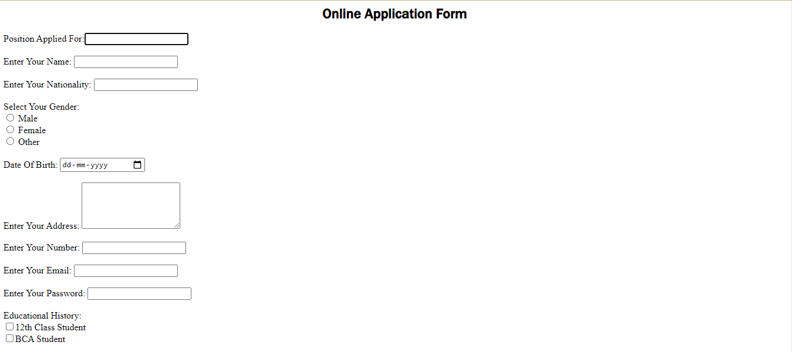



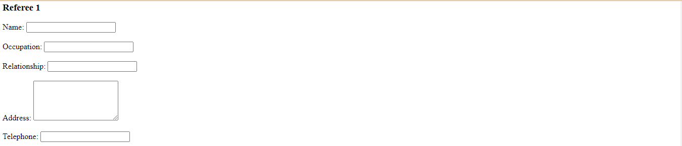

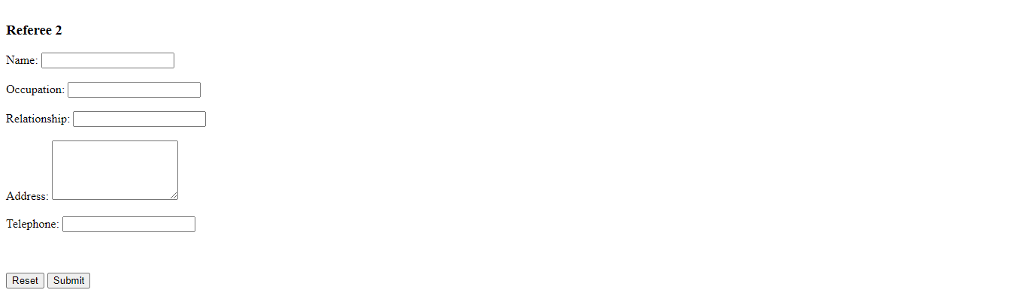

Practical 8

Theory:-

Image map

The HTML <map> tag defines an image map. An image map is an image with clickable areas. The areas are defined with one or more <area> tags.

Usemap attribute

The usemap value starts with a hash tag # followed by the name of the image map, and is used to create a relationship between the image and the image map.

• Use the HTML <map> element to define an image map

• Use the HTML <area> element to define the clickable areas in the image map

• Use the HTML usemap attribute of the <img> element to point to an image map

Code:-

<html lang="en">

<head>

<meta charset="UTF-8" />

<meta http-equiv="X-UA-Compatible" content="IE=edge" />

<meta name="viewport" content="width=device-width, initial-scale=1.0" />

<title>Image Map</title>

</head>

<body>

<img

src="Media/indiamap.png"

alt="Map Of India "

usemap="#indiamap"

width=""

/>

<map name="indiamap">

<area

target="_blank"

alt="Uttar Pradesh"

title="Uttar Pradesh"

href="https://edistrict.up.gov.in/edistrictup/"

coords="1319,867,897,689,1013,922,1116,1017,1281,1091,1328,933,1321,902,1321,885,897,728,1022,973,1109,992,916,832"

shape="poly"

/>

<area

target="_blank"

alt="Rajasthan"

title="Rajasthan"

href="https://rajasthan.gov.in/"

coords="703,1169,938,900,709,675,450,827,443,955,612,1062,650,1104"

shape="poly"

/>

<area

target="_blank"

alt="Uttarakhand"

title="Uttarakhand"

href="https://edistrict.uk.gov.in/"

coords="936,647,1072,748,1122,664,1059,596,991,590,975,627"

shape="poly"

/>

<area

target="_blank"

alt="Jammu &amp; Kashmir"

title="Jammu &amp; Kashmir"

href="https://www.jk.gov.in/jkeservices/"

coords="652,176,788,132,865,205,911,246,973,249,955,260,1019,233,1072,246,1070,326,1048,356,1028,363,1010,381,1008,400,1037,427,1039,447,1039,471,1026,480,1013,480,991,471,964,469,933,444,909,447,881,433,856,433,834,436,823,447,806,473,786,484,746,471,716,449,698,433,678,420,709,301,709,275,685,249,656,218,623,209"

shape="poly"

/>

<area

target="_blank"

alt="Panjab"

title="Panjab"

href="http://edistrict.punjabgovt.gov.in/eda/landing.aspx"

coords="755,517,795,510,812,524,819,543,830,563,852,581,861,596,872,623,867,636,856,647,841,651,828,664,821,680,799,675,784,677,757,669,716,660,694,655,689,629"

shape="poly"

/>

</map>

</body>

</html>

Output:-

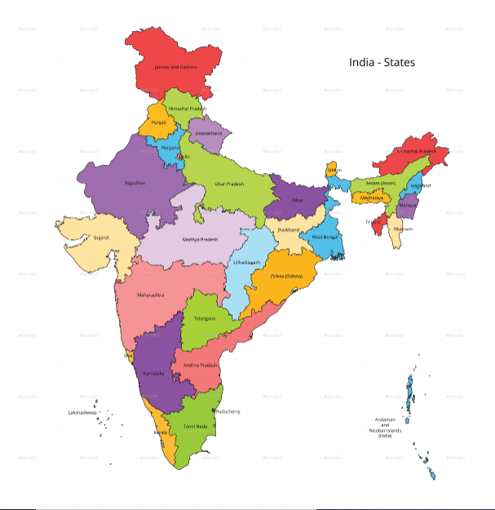

Practical 9

Theory:-

HTML Frames

HTML frames are used to divide your browser window into multiple sections where each section can load a separate HTML document. A collection of frames in the browser window is known as a frameset.

To use frames on a page we use <frameset> tag instead of <body> tag. The <frameset> tag defines, how to divide the window into frames. The rows attribute of <frameset> tag defines horizontal frames and cols attribute defines vertical frames. Each frame is indicated by <frame> tag and it defines which HTML document shall open into the frame.

Attributes

• Src :- This attribute is used to give the file name that should be loaded in the frame.

• Name :- This attribute allows you to give a name to a frame. It is used to indicate which frame a document should be loaded into.

• Frameborder :- This attribute specifies whether or not the borders of that frame.

• Marginwidth :- This attribute allows you to specify the width of the space between the left and right of the frame's borders and the frame's content.

• Marginheight :- This attribute allows you to specify the height of the space between the top and bottom of the frame's borders and its contents.

• Scrolling :- This attribute controls the appearance of the scrollbars that appear on the frame. This takes values either "yes", "no" or "auto".

Code:-

<html lang="en">

<head>

<meta charset="UTF-8" />

<meta http-equiv="X-UA-Compatible" content="IE=edge" />

<meta name="viewport" content="width=device-width, initial-scale=1.0" />

<title>Frames</title>

<style>

iframe{

padding: 0;

margin: 0;

}

div

{

text-align: center;

}

</style>

</head>

<body>

<div>

<iframe

src="Media/audio.mp3"

width="80%"

height="250"

frameborder="1"

style="background: brown;"

allowfullscreen=""

allow="fullscreen; picture-in-picture"

></iframe>

<iframe src="Media/4.png" style="display: inline-block;" width="33%" height="40%" frameborder="1"></iframe>

<iframe src="Media/video.mp4" width="46.3%" height="40%" frameborder="1"></iframe>

</div>

</body>

</html>

Output:-

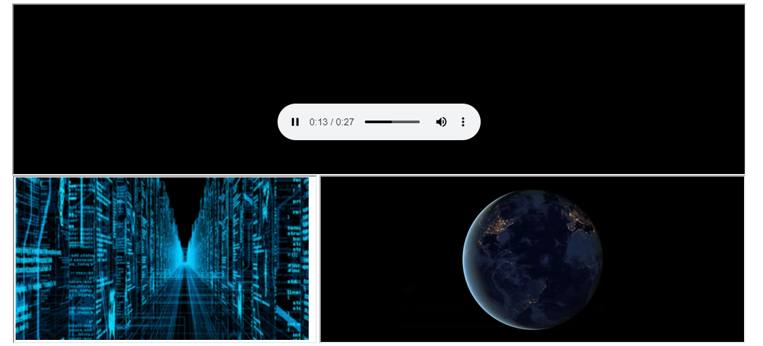

Practical 10

Theory:-

HTML Iframe tag

The iframe HTML element represents a nested browsing context, embedding another HTML page into the current one. The iframe tag defines a rectangular region within the document in which the browser can display a separate document, including scrollbars and borders. An inline frame is used to embed another document within the current HTML document.

Attributes

• Src :- This attribute is used to give the file name that should be loaded in the frame. Its value can be any URL.

• Name :- This attribute allows you to give a name to a frame. It is used to indicate which frame a document should be loaded into. This is especially important when you want to create links in one frame that load pages into another frame, in which case the second frame needs a name to identify itself as the target of the link.

• Frameborder:- This attribute specifies whether or not the borders of that frame are shown; it overrides the value given in the frameborder attribute on the frameset tag.

• Marginwidth:- This attribute allows you to specify the width of the space between the left and right of the frame's borders and the frame's content.

• Scrolling:- This attribute controls the appearance of the scrollbars that appear on the frame.

Code:-

<html lang="en">

<head>

<meta charset="UTF-8">

<meta http-equiv="X-UA-Compatible" content="IE=edge">

<meta name="viewport" content="width=device-width, initial-scale=1.0">

<title> 6 Frames</title>

<style>

iframe

{

margin: 5%;

height: 500;

margin-left: 0;

margin-right: 0;

}

</style>

</head>

<body>

<iframe

src="https://www.nerdsflow.com/"

width="100%"

height="300"

style="border: 2px solid black;"

>

</iframe><iframe

src="https://www.tusharojha.com/"

width="100%"

height="300"

style="border: 2px solid black"

>

</iframe><iframe

src="https://www.ranveer.com/"

width="100%"

height="300"

style="border: 2px solid black"

>

</iframe><iframe

src="https://www.bps.in/"

width="100%"

height="300"

style="border: 2px solid black"

>

</iframe><iframe

src="https://www.expert.ai/"

width="100%"

height="300"

style="border: 2px solid black"

>

</iframe><iframe

src="https://www.britannica.com/topic/history"

width="100%"

height="300"

style="border: 2px solid black"

>

</iframe>

</body>

</html>

Output:-

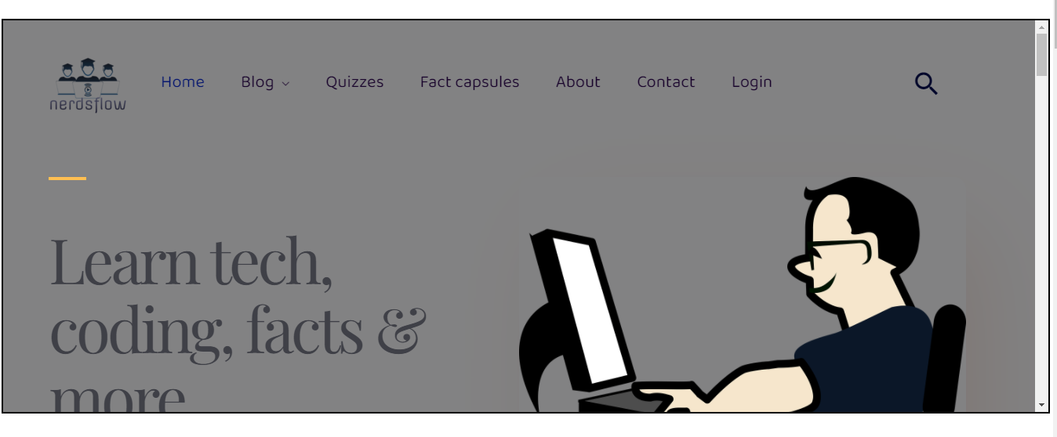



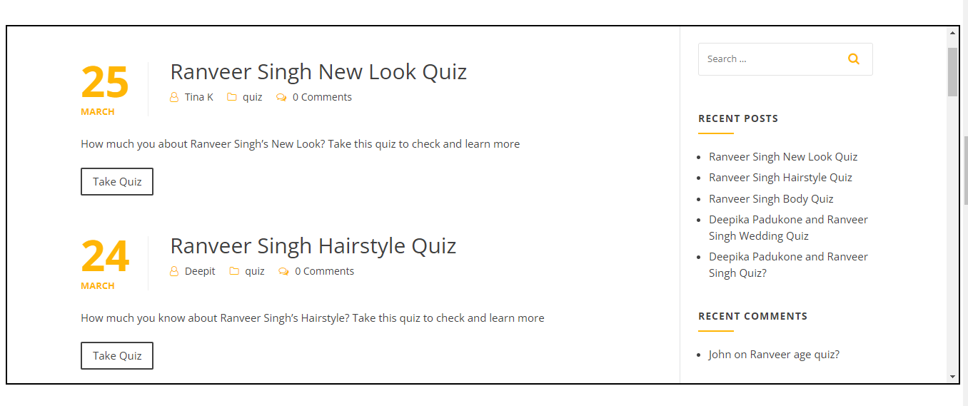

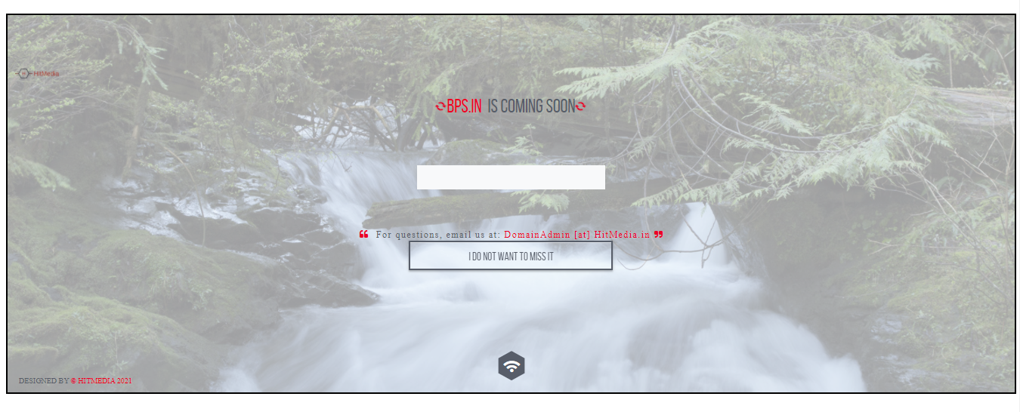



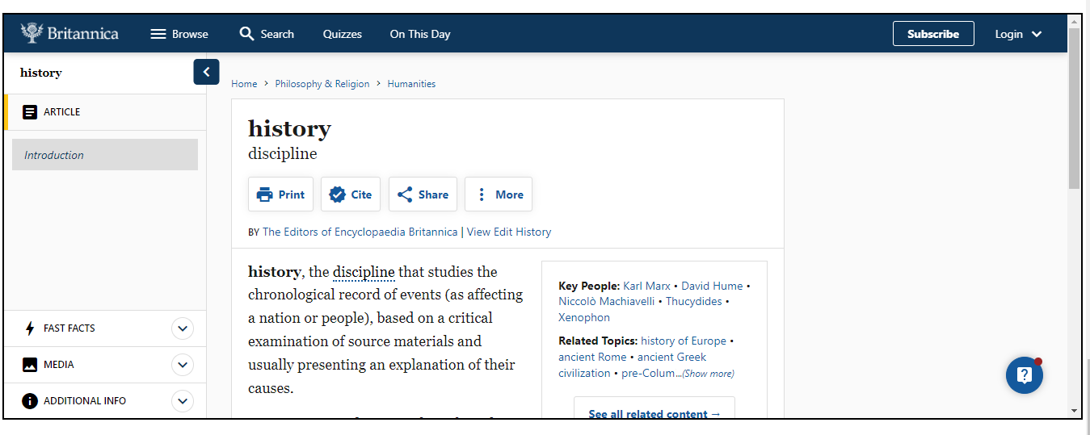

Practical 11

Code:-

<html lang="en">

<head>

<meta charset="UTF-8" />

<meta http-equiv="X-UA-Compatible" content="IE=edge" />

<meta name="viewport" content="width=device-width, initial-scale=1.0" />

<title>Frameset</title>

<style>

a {

text-decoration: none;

color: black;

text-align: left;

font-weight: bolder;

font-family: Cambria, Cochin, Georgia, Times, "Times New Roman", serif;

}

</style>

</head>

<body>

<header style="border: 1px solid black">

<h3 style="display: inline">

<img

style="margin-left: 20px; margin-bottom: 10px"

src="Media/National_Institute_of_Open_Schooling.png"

width="8%"

alt=""

/>

</h3>

<h1

style="

display: inline;

margin-left: 20%;

position: absolute;

line-height: 40px;

top: 20px;

"

>

National Institute of Open Schooling (NIOS)

<br />

<span style="font-size: x-large; margin-left: 20%">

B-31B, Kailash Colony, New Delhi-18</span

>

<br />

<span style="font-size: x-large; margin-left: 22%">

Website:

<a

style="text-decoration: none; color: black"

target="_blank"

href="https://www.nios.ac.in"

>https://www.nios.ac.in</a

>

</span>

</h1>

</header>

<table style="border: 1px solid black">

<tr>

<td style="border-right: 1px solid black; padding-right: 70px">

<ul>

<li>

<a

href="https://www.nios.ac.in/departmentsunits/academic.aspx"

target="frame"

>Academic Programmes</a

>

</li>

<br /><br />

<li>

<a

href="https://www.nios.ac.in/departmentsunits/vocational-education.aspx"

target="frame"

>Vocational Education</a

>

</li>

<br /><br />

<li>

<a

href="https://www.nios.ac.in/notice-boardoffice-order.aspx"

target="frame"

>Examination</a

>

</li>

<br /><br />

<li>

<a

href="https://www.nios.ac.in/departmentsunits/administration.aspx"

target="frame"

>Administration</a

>

</li>

<br /><br />

<li>

<a

href="https://sdmis.nios.ac.in/registration/locate-study-center"

target="frame"

>Study Center</a

>

</li>

<br /><br />

<!-- <li><a href="" target="frame">FAQ</a></li><br><br> -->

<li>

<a href="https://www.nios.ac.in/contact-us.aspx" target="frame"

>Contact us</a

>

</li>

</ul>

</td>

<td>

<iframe

src=""

frameborder="0"

title="Right frame"

name="frame"

width="1100px"

height="585px"

>

</iframe>

</td>

</tr>

</table>

<footer>

<h3 style="text-align: center; border: 1px solid black; margin: 0%">

Website Designed & Developed By

<a target="_blank" href="https://www.nios.ac.in"

>National Institute of Open Schooling (NIOS)</a

>

<br />

For any Query Contact

<a target="_blank" href="https://linktr.ee/imamantripathi"

>Aman Tripathi</a

>

</h3>

</footer>

</body>

</html>

Output:-

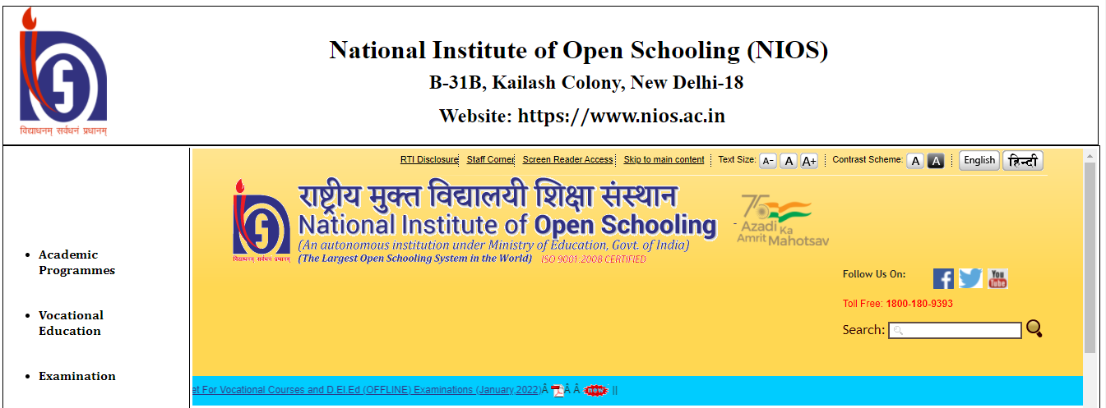

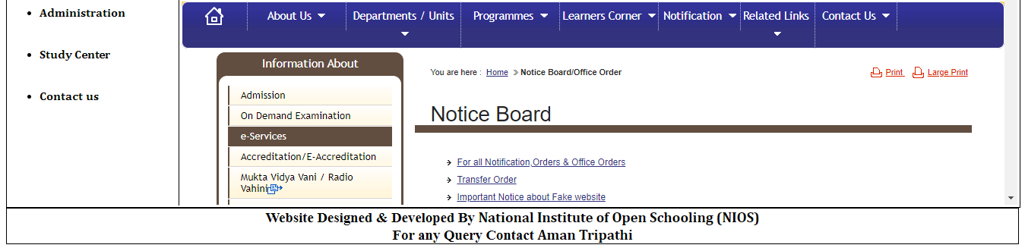

Practical 12

Code:-

<!DOCTYPE html>

<html lang="en">

<head>

<meta charset="UTF-8" />

<meta http-equiv="X-UA-Compatible" content="IE=edge" />

<meta name="viewport" content="width=device-width, initial-scale=1.0" />

<title>Iframe Example</title>

</head>

<body style="border: 1px solid black; padding: 10px">

<h3>

The Taj Mahal'Crown of the Palace' is an ivory-white marble mausoleum on

the right bank of the river Yamuna in the Indian city of Agra. It was

commissioned in 1632 by the Mughal emperor Shah Jahan (r. 1628–1658) to

house the tomb of his favourite wife, Mumtaz Mahal; it also houses the

tomb of Shah Jahan himself. The tomb is the centrepiece of a 17-hectare

(42-acre) complex, which includes a mosque and a guest house, and is set

in formal gardens bounded on three sides by a crenellated wall.

</h3>

<iframe

src="https://upload.wikimedia.org/wikipedia/commons/thumb/d/da/Taj-Mahal.jpg/200px-Taj-Mahal.jpg"

width="200px"

height="133px"

frameborder="4"

>

</iframe>

<h3>

he most spectacular feature is the marble dome that surmounts the tomb.

The dome is nearly 35 metres (115 ft) high which is close in measurement

to the length of the base, and accentuated by the cylindrical "drum" it

sits on, which is approximately 7 metres (23 ft) high. Because of its

shape, the dome is often called an onion dome or amrud (guava dome).[19]

The top is decorated with a lotus design which also serves to accentuate

its height. The shape of the dome is emphasised by four smaller domed

chattris (kiosks) placed at its corners, which replicate the onion shape

of the main dome. The dome is slightly asymmetrical.[20] Their columned

bases open through the roof of the tomb and provide light to the interior.

Tall decorative spires (guldastas) extend from edges of base walls, and

provide visual emphasis to the height of the dome. The lotus motif is

repeated on both the chattris and guldastas. The dome and chattris are

topped by a gilded finial which mixes traditional Persian and Hindustani

decorative elements.[21] The main finial was originally made of gold but

was replaced by a copy made of gilded bronze in the early 19th century.

This feature provides a clear example of integration of traditional

Persian and Hindu decorative elements.[22] The finial is topped by a moon,

a typical Islamic motif whose horns point heavenward.[23] The minarets,

which are each more than 40 metres (130 ft) tall, display the designer's

penchant for symmetry. They were designed as working minarets— a

traditional element of mosques, used by the muezzin to call the Islamic

faithful to prayer. Each minaret is effectively divided into three equal

parts by two working balconies that ring the tower. At the top of the

tower is a final balcony surmounted by a chattri that mirrors the design

of those on the tomb. The chattris all share the same decorative elements

of a lotus design topped by a gilded finial. The minarets were constructed

slightly outside of the plinth so that in the event of collapse, a typical

occurrence with many tall constructions of the period, the material from

the towers would tend to fall away from the tomb.[24]

</h3>

</body>

</html>

Output:-

